Buttons and switches are a fundamental part of ‘physical’ computing. This beginner’s tutorial is designed to teach the basics of physical operation with the Raspberry Pi using a simple momentary switch set-up. In part one, we discussed and built our switch circuit. In this part, we’ll go through the steps of programming and interacting between the Pi and our components. We’ll then build an LED expansion to our circuit, ready for programming in the next edition!
Making a Program in Python
The coding part of this tutorial will be completed on Python, a widely used general purpose language. It’s also very readable, so we can break down and explain the function of each line of code. The purpose of our code will be to read the I/O pin when the switch is pressed. This guide will be completed on Raspian (the recommended OS), which comes complete with the Python library & Python programming software.
Boot up the Raspian GUI with startx, and load the program IDLE 3 into which we’ll type our code. As we’re starting a new project, open up a new window File>>New Window. Remember that Python is case sensitive, and indentation is fundamental. Indentation, which is used to group statements, will occur automatically as you type commands, so make sure you stick to the suggested layout.
The first line of our code imports the Python GPIO library, which provides GPIO classification to control the Raspberry Pi GPIO pins via Python.
import RPi.GPIO as GPIO
We next need to set our GPIO pin numbering, as either the BOARD numbering or the BCM numbering. BOARD numbering refers to the physical pin numbering of the headers. BCM numbering refers to the channel numbers on the Broadcom chip. Either will do, but I personally prefer BCM numbering. If you’re confused, use a GPIO cheat sheet to clarify which pin is which!
GPIO.setmode(GPIO.BCM)
Now we need to define the GPIO pins as either Inputs or Outputs. In Part 1, we set GPIO P17 [Pin 11] as our input pin. So, our next line of code tells the GPIO library to set this pin as an input. Note; we’re using BCM numbering, so the defined pin is “17”. If we were using BOARD numbering, it would be pin “11”.
GPIO.setup(17, GPIO.IN)
In the previous tutorial, the input pin was tied high by connecting it to our 3.3V pin. The purpose of our Python programme is to check if the input pin has been bought low, which occurs when the button has been pressed. To check the high/low status of the pin we’re going to use a True or False statement running on an infinite loop.
We need to tie our true statement to the high value of our input pin. To do this, we create a new variable called input_value and set it the current value of GPIO P17 [Pin 11]. This will set the variable to the value of the input pin when the script is run. As this input pin is tied high, it will set the variable high.
while True:
input_value = GPIO.input(17)
Next, we'll add some code so that the program will display a message when the button is pressed. For this, we’ll use the False statement and the print command. When the input_value (which is tied high) is pulled low, which occurs when the button is pressed, execute the print command.
If input_value == False
print(''Who pressed my button!”)
We’ve selected the Print command, which simply displays a message in the terminal when it’s activated. When the button is pressed the program will now display the text: “Who pressed my button!”. Feel free the change this to anything you want.
The last two lines in the code are very important, they create a loop that tells Python to keep checking the status of GPIO P17 [Pin 11] until it's no longer low (button released). Without this, the program would loop while the button is still being pressed meaning the message could be printed multiple times on the screen before you release the button.
while input_value == False:
input_value = GPIO.input(17)
The final program should look like this in python:
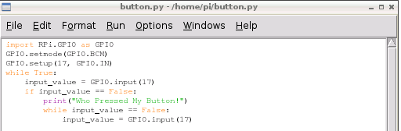
Save the file as “button.py” (or any other name you like) and make sure it’s saved in your home directory for ease of access. If you save it in a new directory, make sure you change to the correct directory first using the CD command before you run it.
In order to run the program, open a new terminal window on the Pi and type the following command (or replace the name of the file with your own file name if you changed it):
sudo python button.py
At first nothing will happen, but if you press the button the program will print your message!
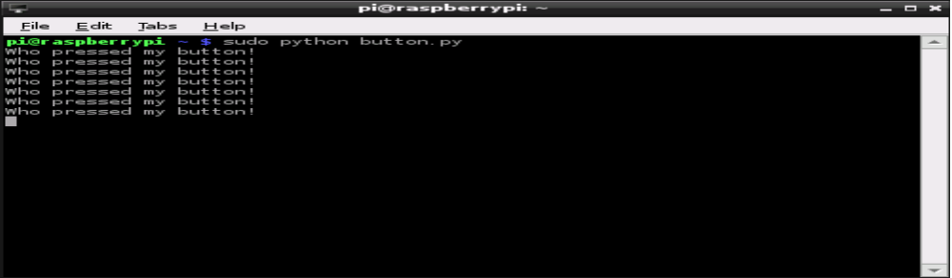
To exit a running Python script, simply hit CTRL+C on the keyboard to interrupt it. If you terminate a script, or a script ends whilst a GPIO pin is mid-way through a task (such as outputting 3.3V), or set as an input, it will stay in the same status. Terminating mid script will work in this case, but having pins running random functions isn’t ideal, hence this is why it’s good practice to initiate a clean-up operation! We’ll go through how to properly terminate and clean-up a Python script in the next tutorial.
If you pressed you button and it hasn't worked, don't worry. First, check the circuit is connected correctly on the breadboard as defined in part 1, then that the jumper wires are connected to the correct pins on the GPIO port. If it still fails to work, double check each line on the program is correct, remembering that python is case-sensitive and indentation is correct. I find that carefully typing the code out by hand will give better results than a simple copy/paste.
This is a deceptively simple program that can be used for many purposes. The same code could be used to read when the pins of separate devices, such as a sensor or external micro-controller, have been pulled high or low.
Now we’ll expand our circuit by adding an LED, and making it flash on command from our button!
The LED Circuit
We'll carry on using the same breadboard as before but will require a couple extra components:
- An LED (light emitting diode), any colour you like.
- ModMyPi’s Ridiculous Resistor Kit (RK995)
  - 330Ω Resistor - (Orange, Orange, Black, Black, Brown)
An output pin on the GPIO port can be set to either 0V (low) or 3.3V (high). Our expansion circuit will wire up an LED between an output pin and a ground pin on the Raspberry Pi's GPIO port. We’ll be using Python to trigger our output pin high, causing a current to pass through the LED, lighting it up! We also add a 330Ω Resistor to limit the current that is passed through the LED.
For this exercise we will connect the LED to GPIO P18 [Pin 12] which will be defined later in our program as an output. We will use the same the ground pin GPIO GND [Pin 6] as before which is already connected to the Negative rail (-) on our breadboard.
Building the Circuit
1. Connect GPIO output to breadboard. Use a green jumper wire to connect GPIO P18 [Pin12] on the Pi to an empty to row on the breadboard
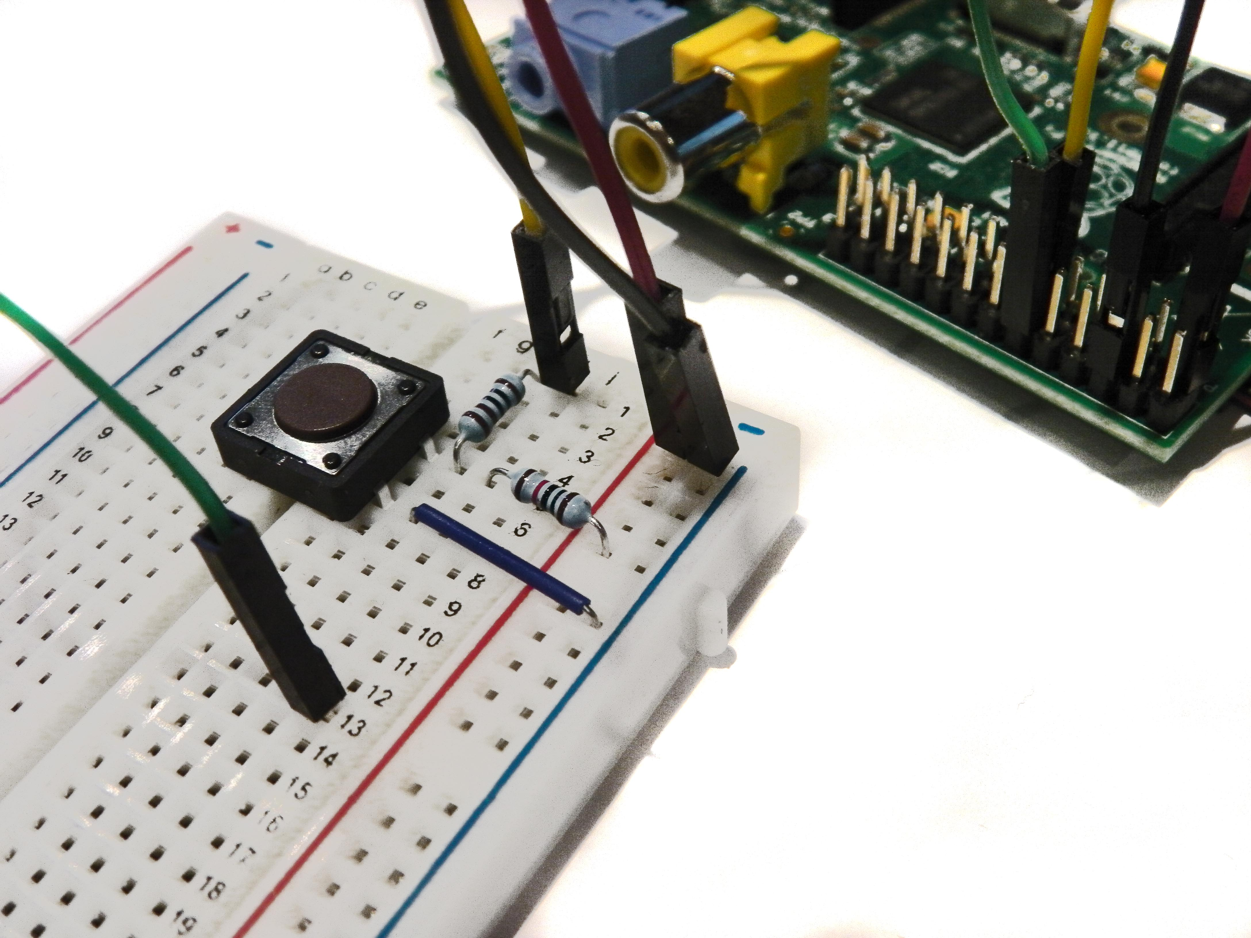
2. Add an LED. Insert the long leg (anode) of the LED into the same row as the green jumper wire and insert the shorter leg (cathode) into another empty row on the breadboard. Note: Make sure the LED is inserted the correct way round as it will only allow current to pass through it in one direction. If it's wrong it won't light up!
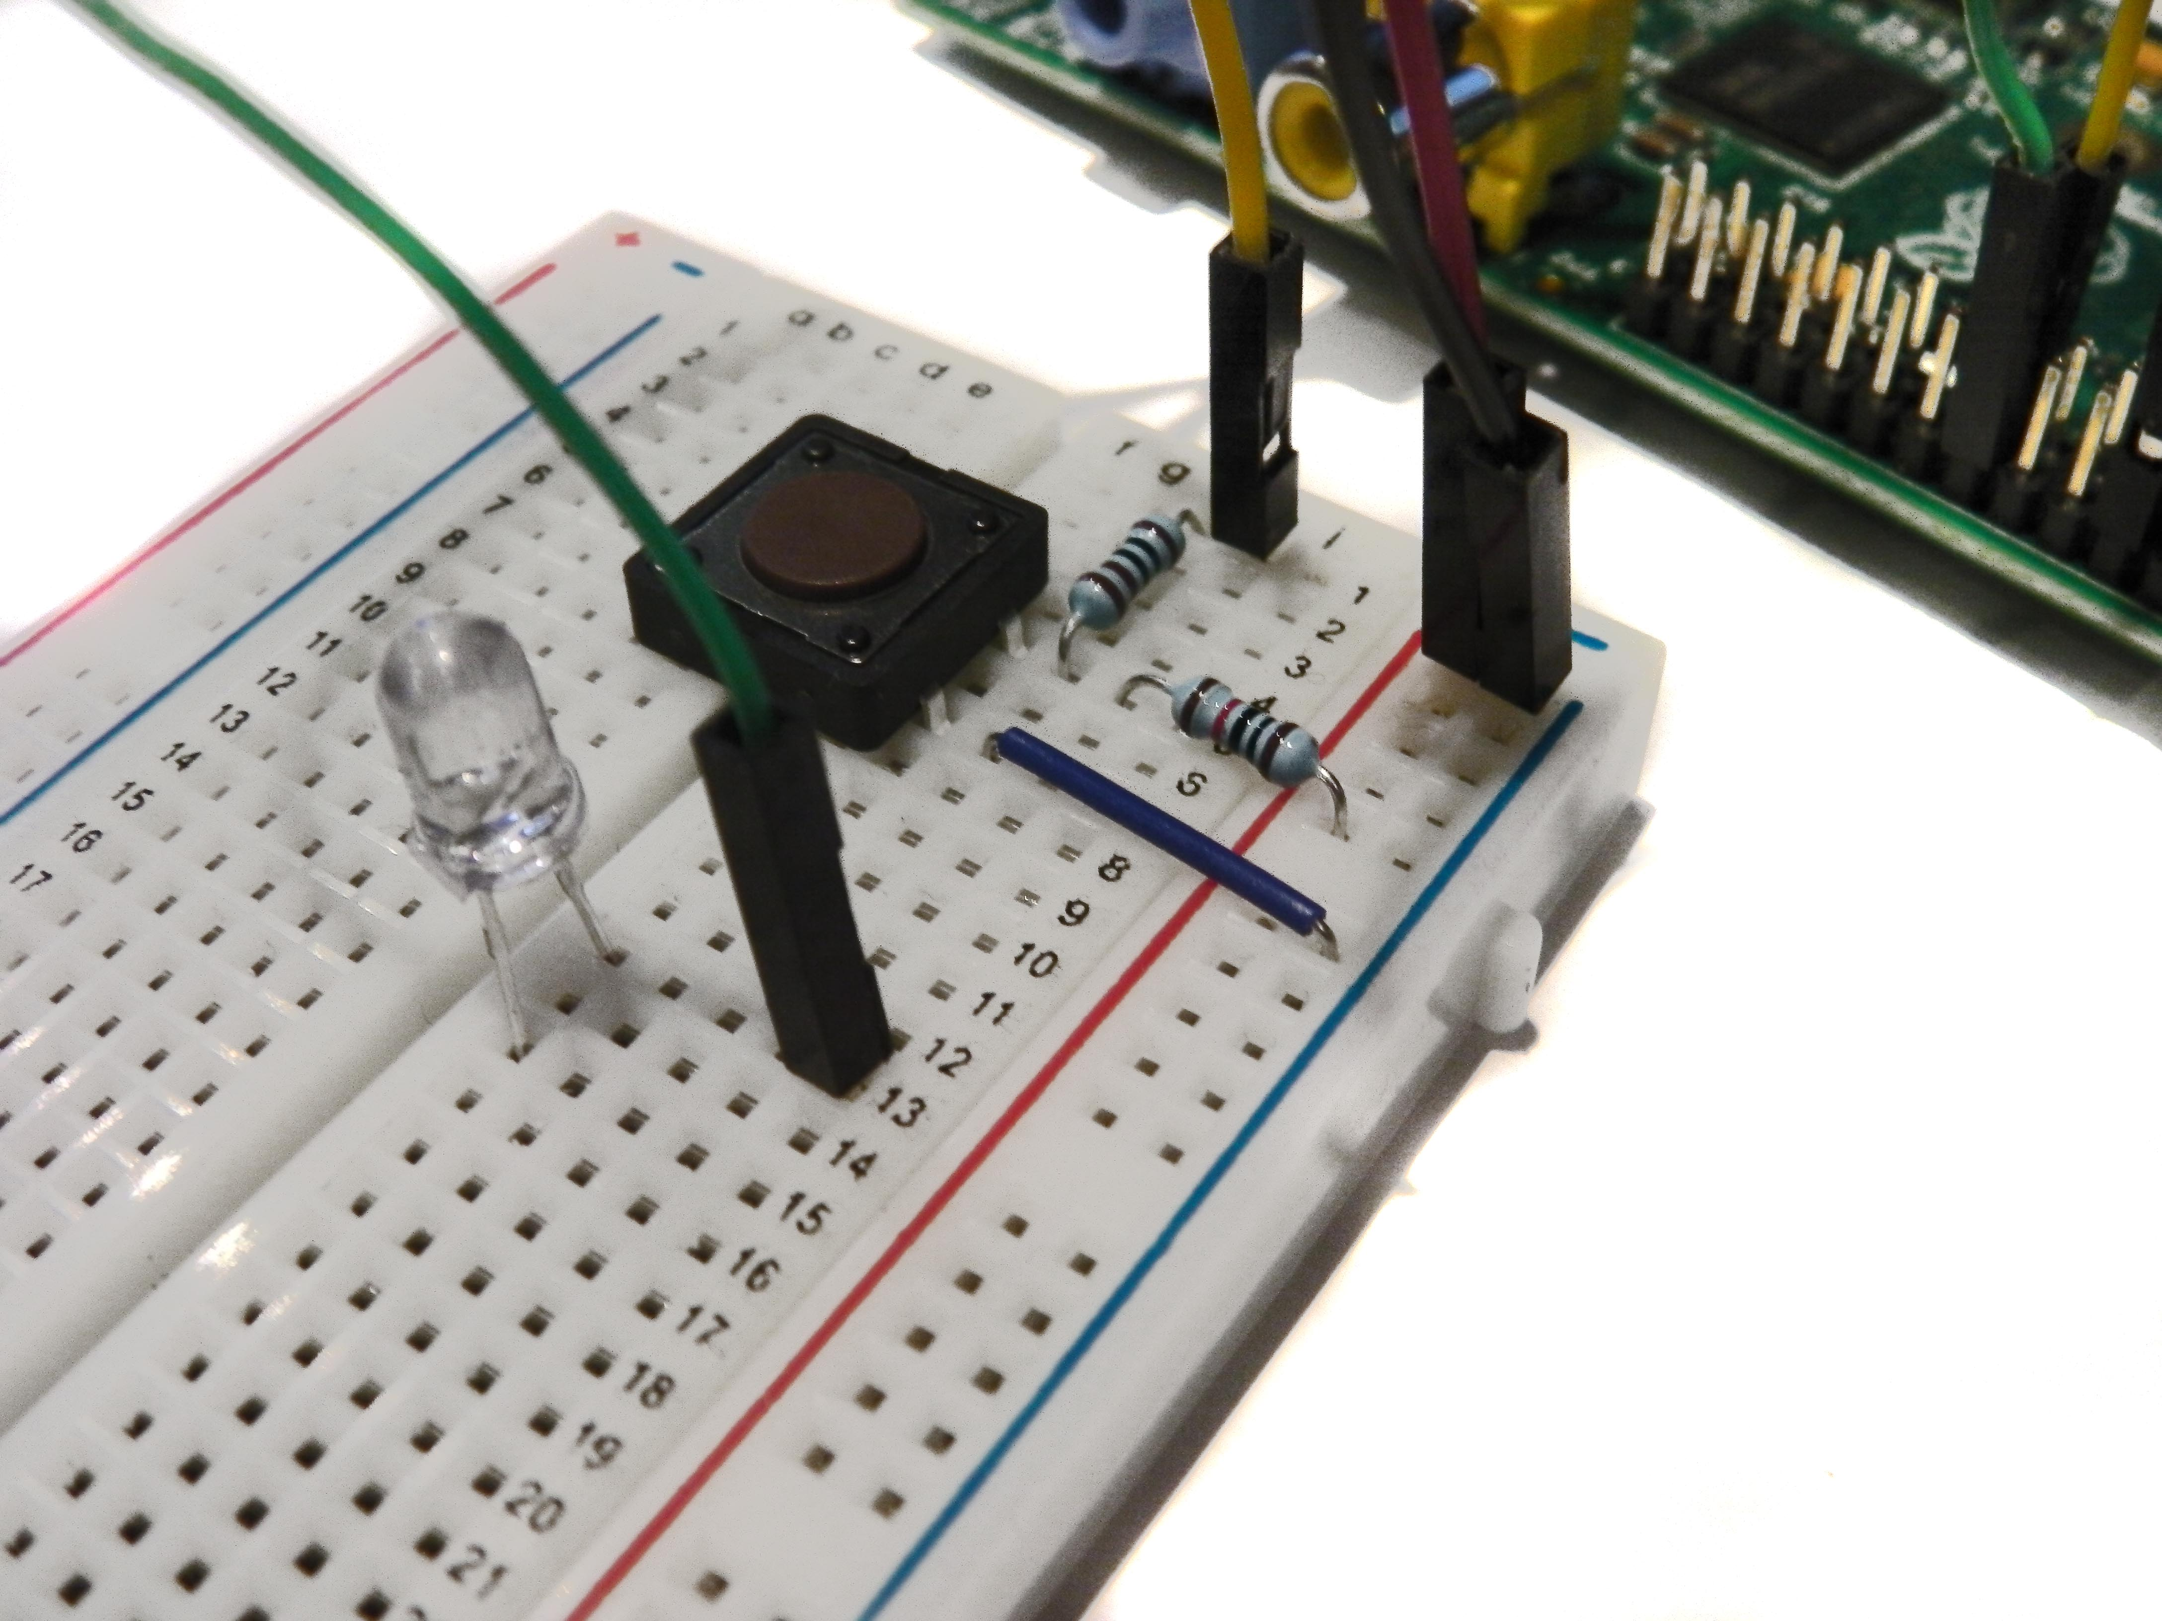
3. Add 330Ω Resistor. Connect the resistor between the cathode of the LED and the Negative rail (-) on the breadboard. This protects our LED from burning out by way of too much current.
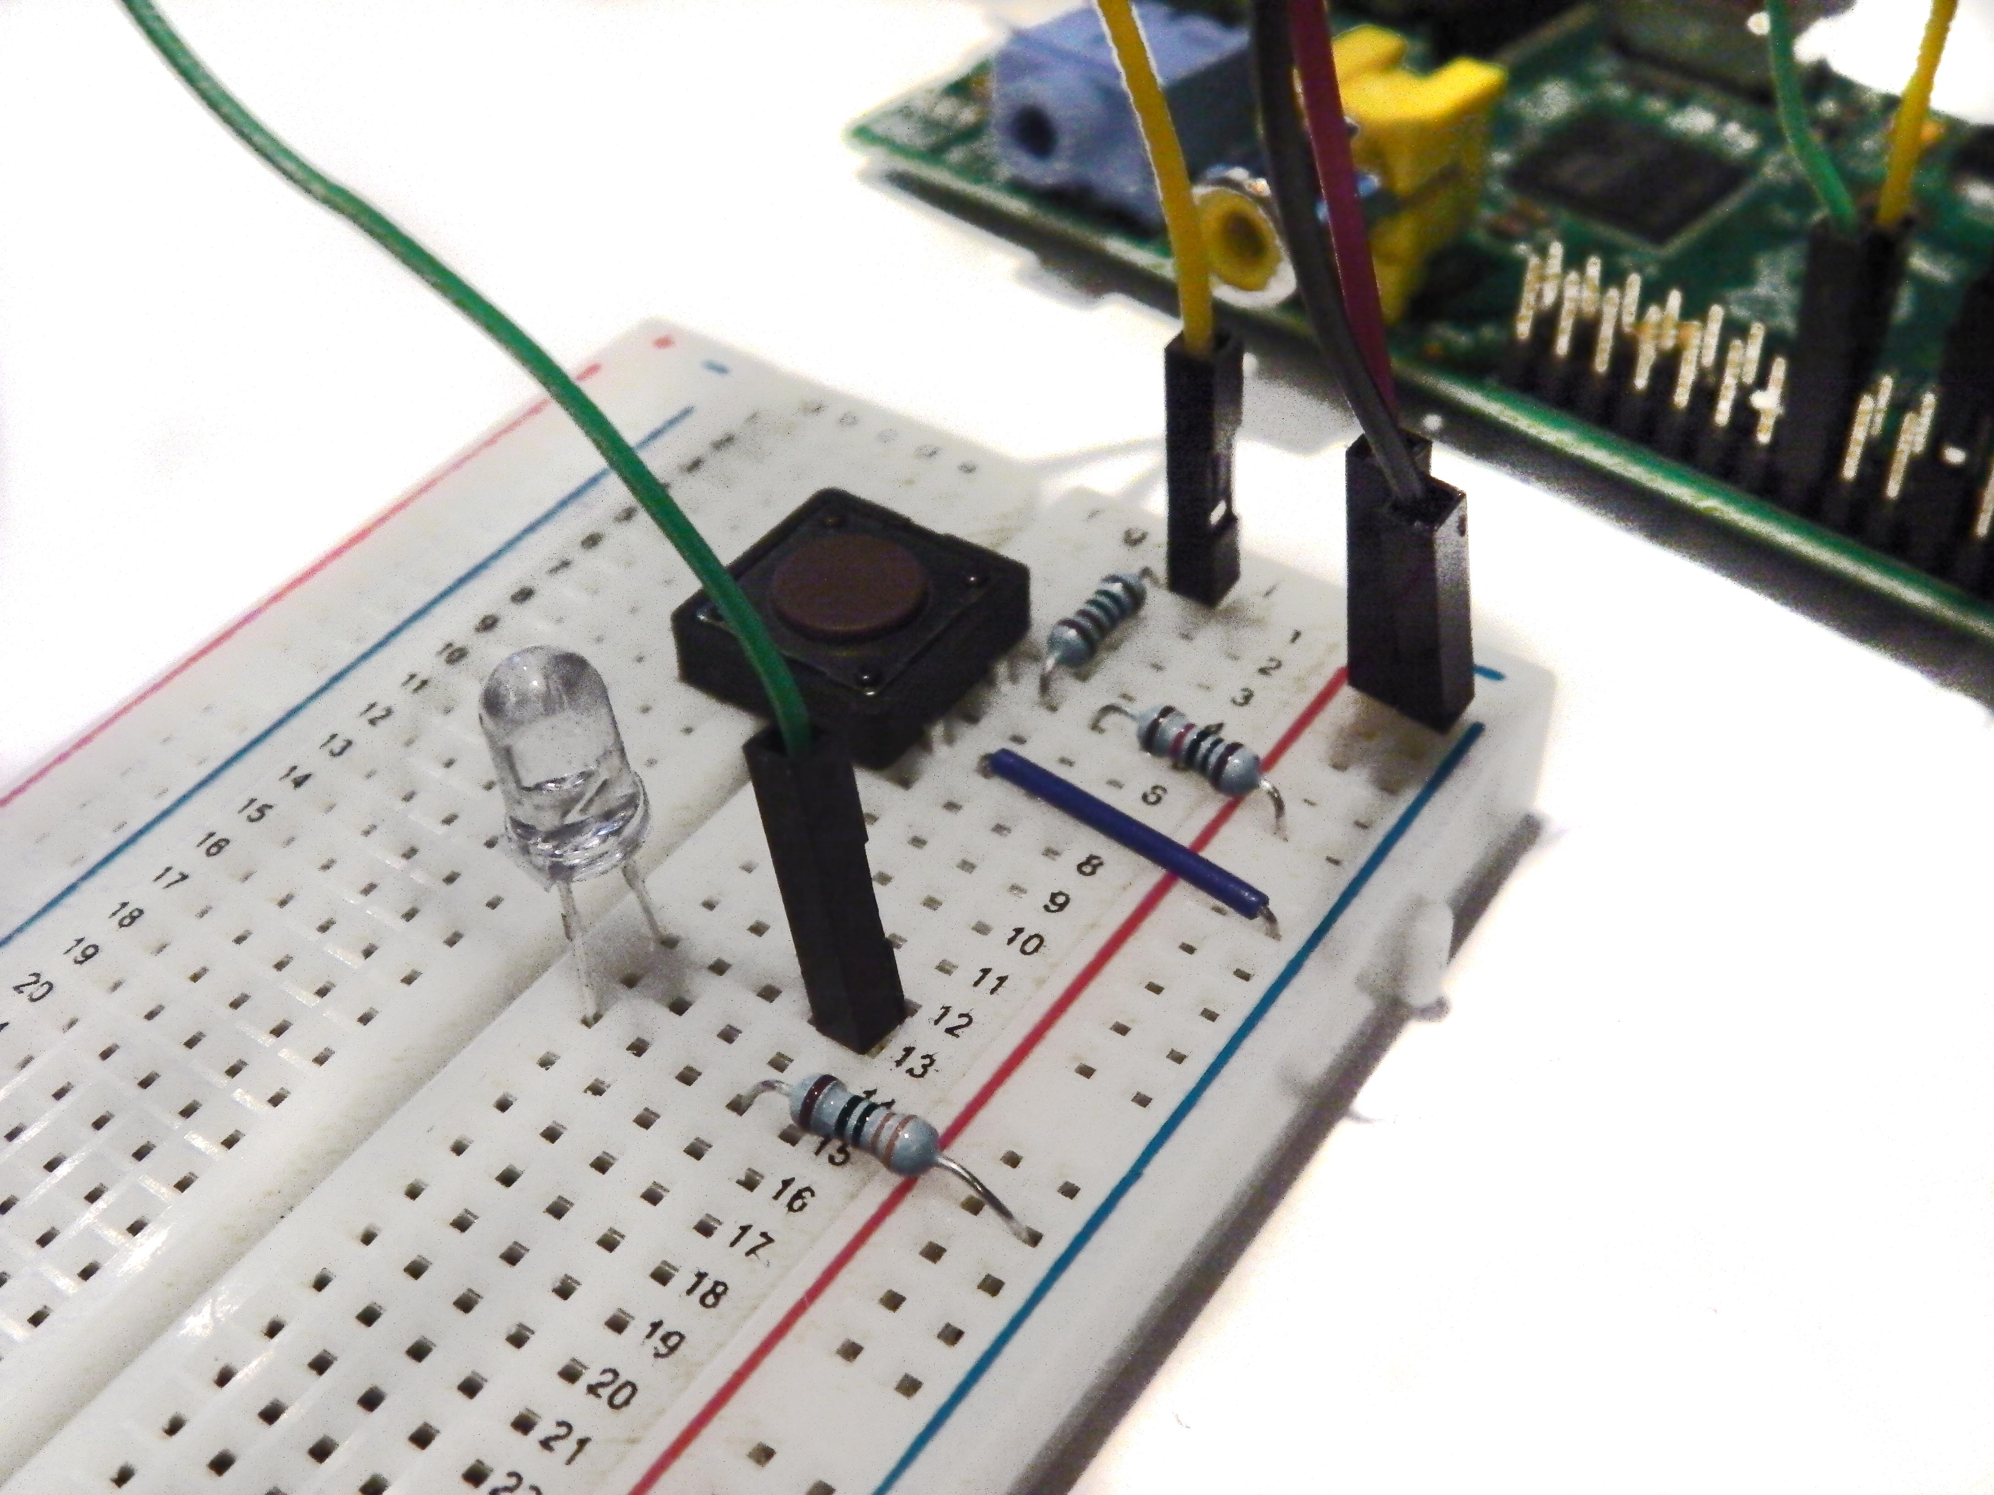
And that's our circuit built!
Next time, we’ll add a timer function to our script and a trigger function for our LED. As the script will be more complicated, it requires a proper clean-up function, so we’ll code that in too!

